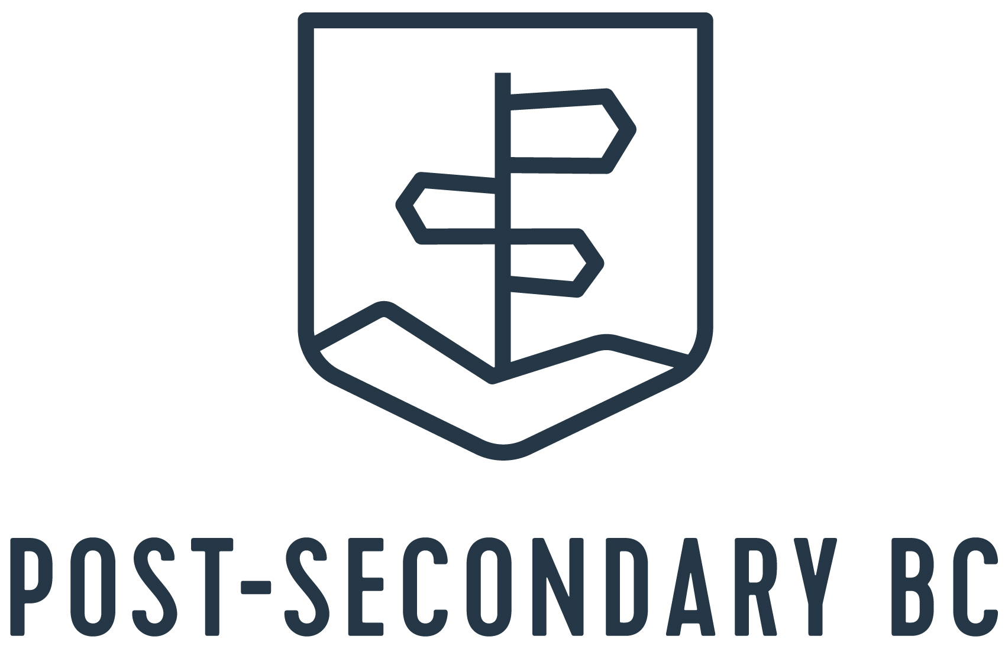
Member Replies to Questions about STS and Assessment Results
Question # 1 - What does your institution want – or not want – with regard to Transcripts and STS:
1. Do you want transcripts?
2. Do you want them only through STS?

Question # 2 - What are institutions planning to do with Numeracy and Literacy Assessment Results?
1. Are you going to do anything with them?
2. If YES, what are you going to do?

British Columbia Institute of Technology [BCIT]
TRANSCRIPTS:
- BCIT’s application process is entirely online. Students will self-report their grades using their scanned transcripts and uploading it to their online application.
- NO
ASSESSMENT RESULTS:
- NO

Camosun College

TRANSCRIPTS:
- YES - We want transcripts 2. YES – We want it through STS
ASSESSMENT RESULTS:
- We don’t use them, but it has come through as part of the import.

Canadian Forces - Royal Military College

TRANSCRIPTS:
- Yes, we want transcripts. 2. NO – Hard copy is a must.
ASSESSMENT RESULTS:
- NO

Capilano University
TRANSCRIPTS:
- Yes, we want transcripts through EPBC upload.
- Yes, we would like to use STS for updated interim and final grades.

ASSESSMENT RESULTS:
- NO

Coast Mountain College
TRANSCRIPTS:
- YES – We still require transcripts. 2. NO - CMTN is not ready to accept STS.
ASSESSMENT RESULTS:
- NO

College of New Caledonia
TRANSCRIPTS:
- YES - We want final official transcripts from the Ministry and will accept (& require) Diploma Verifications with interim grades.
- 2. NO - We will be setting up to receive electronic transcripts from the Ministry later this year. For students applying before completion of Grade 12 graduation we require diploma verifications via email: regoffice@cnc.bc.ca
ASSESSMENT RESULTS:
- NO

College of the Rockies
TRANSCRIPTS:
- YES
- YES
ASSESSMENT RESULTS:
- NO, we only enter them into Colleague; beyond that, nothing else at this point in time.

Corpus Christi & St. Mark’s Colleges
TRANSCRIPTS:
- YES
- NO
ASSESSMENT RESULTS:
- NO

Douglas College
TRANSCRIPTS:
- YES, interim when available, and final.
- YES - Only through STS delivered electronically via the delivery system. PDF/Emailed/Paper transcripts will not be reviewed. Any student concerns with their transcripts can be directed to their Admissions officer once they’ve applied.

ASSESSMENT RESULTS:
- NO - Not using them for evaluation and not included in any specific Admissions Requirements for any program.

Emily Carr University of Art and Design
TRANSCRIPTS:
- YES - Interim transcripts can be emailed to admissions@ecuad.ca. Final transcripts need to be original in sealed envelope.
- NO
ASSESSMENT RESULTS:
- NO - Proof of English 12 with a C or higher.

Fairleigh Dickinson University
TRANSCRIPTS:
- YES - Uploaded copies on our online application portal and official document are required at new student orientation.
- NO
ASSESSMENT RESULTS:
- NO

Justice Institute of BC

Kwantlen Polytechnic University
TRANSCRIPTS:
- Yes, we will need transcripts for all applicants. Self-reported grades should only be provided if an applicant is asked to provide them as they are only required for certain competitive admission programs.
- 2. Yes, we would like to receive all HS interim and final transcripts through STS.
ASSESSMENT RESULTS:
- NO - At this time, assessment results are not being used in selecting qualified candidates for admission.

Langara College
TRANSCRIPTS:
- STS transcripts but ONLY after interim grades become available; we often receive transcripts too early with no Grade 12 courses even listed yet and we have to go back to the student to request another.
ASSESSMENT RESULTS:
- YES - Langara admissions can access and request updates for XML BC High school transcripts during the period that the students have given us access. We only check to see that the Numeracy and Literacy Assessments have been completed since they are required for high school graduation; we won’t consider the results.
Nicola Valley Institute of Technology
TRANSCRIPTS:
- Yes, transcripts wanted, and through STS if possible.
ASSESSMENT RESULTS:
NO
Northern Lights College
TRANSCRIPTS:
- YES
- NO – STS is preferred but any method is fine.
ASSESSMENT RESULTS:
- Not at this time.

North Island College
TRANSCRIPTS:
- NIC does require transcripts.
- NO – NIC can receive them by mail, by fax directly from their high school, or students can access their transcript through STS and request that NIC receive them.
ASSESSMENT RESULTS:
- At this time, NIC is not using the literacy and numeracy assessments as an admission requirement for any of our programs. This may change in the future, but for now we are using course specific completion as admission requirements.

Okanagan College
TRANSCRIPTS:
- We always want transcripts, and most come via mail. Hopefully next year, all will be electronic at which point we do not need an actual paper transcript anymore.
- STS is the preferred method. However, we will still accept mailed copies.
ASSESSMENT RESULTS:
- NO
Quest University
TRANSCRIPTS:
- Yes, but we do not require official transcripts when a student initially submits their application to Quest. We have students submit an official transcript after they graduate from high school and choose to enroll at Quest.
- We do not need transcripts submitted through the STS, but if the STS is used a physical copy of the transcript is required. Once a student chooses to enroll at Quest, a student requests their final transcript be sent from the school, and can be uploaded by a link provided, mailed to the Admissions Office or to Admissions@questu.ca
ASSESSMENT RESULTS:
- NO
Royal Roads University

Selkirk College
TRANSCRIPTS:
- Yes, original transcripts are required to be sent directly to RRU from issuing institution.
- NO - not currently using STS.
ASSESSMENT RESULTS:
- Currently, we have no plans to use them for application purposes.

Simon Fraser University
TRANSCRIPTS:
- SFU only wants STS transcripts
ASSESSMENT RESULTS:
- For applicants to the Fall (September) 2022 term, SFU will not consider the results of the Grade 12 Literacy Assessment in the admission evaluation process. Please note, as the Grade 12 Literacy Assessment is required to graduate, and students are require to graduate to be considered for admission to SFU, completing the Grade 12 Literacy Assessment is required to be considered for admission to SFU.

Thompson Rivers University
TRANSCRIPTS:
- YES - Offers only made to students who submitt an official interim or final transcript with their application.
- Students should be using the STS for transcript submission whenever possible. For TRU, it is in the students’ best interest to first apply to TRU (ensuring to include the PEN number on the application) before requesting a transcript through the STS. This process will allow for automatic matching during our download process and will prevent delays and additional request for transcripts. NOTE: The transcript download does not always show courses in progress and/or interim marks. For some programs at TRU {Nursing, Respiratory Therapy, Engineering et.al.} the Admissions Office may request an official report card or Diploma Verification Report from the student showing course in progress, interim marks, and planned courses, if such information is not already indicated in the electronic transcript provided via STS, in order to make an admissions decision.

ASSESSMENT RESULTS:
- NO

Trinity Western University
TRANSCRIPTS:
- TWU can’t receive electronic marks through STS, so we require students to submit to us a photo/scan/PDF of their report cards and/or transcripts for provisional admission as part of our application process. We require the final official mailed copy in the summer showing graduation.
ASSESSMENT RESULTS:
- We require completion of the Numeracy and Literacy assessments to confirm admission, but they aren’t calculated as part of their admission average.
University of British Columbia
TRANSCRIPTS:
- NO - Not if the student provides us with their PEN
- It is best and easiest for a student to provide us with their PEN

ASSESSMENT RESULTS:
- Literacy Assessment- BC high school students graduating in June 2022 who receive a UBC offer of admission will be required to demonstrate a "Proficient" level of performance on the Grade 12 Literacy Assessment to maintain their offer of admission. This requirement must be completed by June 30, and final results are due by the end of July. Applicants who do not achieve a "Proficient" on the assessment will have their offer of admission reviewed on a case-by-case basis.

University of Northern British Columbia
TRANSCRIPTS:
- YES - Students can apply with self-declared grades, but we will need their official final transcripts, so students should sign up to have their transcripts sent through STS.
- Yes, if possible. It makes life much easier for everyone (assuming the STS upload process works!)
ASSESSMENT RESULTS:
- NO - We are not currently evaluating them for admission or scholarship. We continue to look for English 12 and the approved grade 12 courses.

University of the Fraser Valley
TRANSCRIPTS:
- YES
- YES, if possible
ASSESSMENT RESULTS:
- NO – Not at the moment.

University of Victoria
TRANSCRIPTS:
- We do NOT want paper transcripts.
- We only want electronic transcripts through STS.

ASSESSMENT RESULTS:
- NO [not at this time]

Vancouver Community College
TRANSCRIPTS:
- VCC requires official sealed transcripts. We do not yet have the ability to upload via Ed Planner. If upcoming graduates indicate, while in school, that they are applying for post-secondary they can indicate the colleges they will be applying to and VCC can then upload their transcripts through TRAX.
- NO
ASSESSMENT RESULTS:
- VCC is not currently using the numeracy and literacy assessments. We look for completion of high school graduation as well as individually required courses for the program applied to.

Vancouver Island University
TRANSCRIPTS:
- Students outside of BC, or with zero BC coursework, should send official hard copy transcripts.
- BC students (or students with BC high school coursework) should use the Student Transcript Service. Remind them to not change any of the defaults when they arrange to send us transcripts. (For current students - the defaults are to ‘authorize VIU to get updates’, and the default time period for authorization is for ‘1 year from when they make their submission’.
ASSESSMENT RESULTS:
- NO [Reminder to Counsellors: The Numeracy and Literacy Assessments are part of the Grad requirements. We have had a number of students who did not do one/both of the assessments and then could not demonstrate high school graduation and were not able to be admitted to the program of their choice, or not admitted at all.

